**Communication & Collaboration I: Personal Impact**

**A2: Group Assignment Case Study – The Empowerment Plan Presentation**

**Due Friday by 11:59pm**

**Professor Matthew Fisher**

**Team 12 – Scifi 2**

**Sreekar Bathula, Yunsik Choung, Jing Li, Tangina Parvez**

**Submitted Item 1. Document listing the purpose of each slide in the deck.**

**Submitted Item 2. Video Links:** [**https://youtu.be/blTWICBVbcM**](https://youtu.be/blTWICBVbcM)

**Detroit Lions Slide Documents**

We need Lions! - Proposal for CSR Marketing for Lions

**Slide 1**: Contains introductory information



**Slide 2**: Index information

**Slide 3**: Introduce previous work between TEP and Lions

Historical involvement of Detroit Lions in Hopeless people charity.

**Slide 4**: Exacerbation after the Pandemic

Impact of the pandemic and increase of homeless problems in Detroit.

**Slide 5**: What do we want to support?

Goal and expectations for the donation. From temporary sponsorship to regular sponsorship by relating Lions game records for helping the homeless.

**Slide 6**: CSR Marketing Strategies

Strategies and partnership ideas for CSR Marketing to Lions

**Slide 7**: Funding

Funding requirements for the cause.

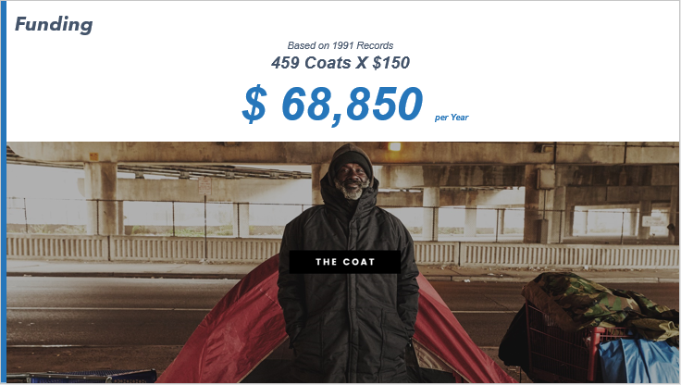

**Slide 8**: What will become True?

Funding investment areas

**Slide. 9**: What will become True?

Explain our hope to rebuild a better life for the homeless people using the donation.

**Slide. 10**: Thank you.

**Bill & Melinda Gates Foundation Slide Documents**

Winter is Coming - Invest in future Detroit

**Slide. 1**: Introductory template.

**Slide. 2**: Index explanation.

**Slide. 3**: Winter is Coming - Emergency of the homeless problem in Detroit

Weather forecast and climate change analysis.

**Slide. 4**: Winter is Coming - Comparison of Detroit with Seattle

On economic issues

**Slide. 5**: Winter is Coming - What makes Detroit too dark?

Describe social and racial facts.

**Slide. 6**: Winter is Coming - Detroit Economy falling

People who abandon the city and take business away leave Detroit economically fragile.

**Slide. 7**: Who TEP are?

**Slide. 8**: What does TEP intend to do?

**Slide. 9**: What we do?

The weather-resistant Coat and its distribution.

**Slide. 10**: Social influences of Bill & Melinda Gates Foundation for EARTH

**Slide. 11**: Social influences of Bilal & Melinda Gates Foundation for Seattle Neighbor

**Slide. 12**: What do we want to support (1)

Proposal for real-estate buying.

**Slide. 13**: What do we want to support (2)

Skill development training.

**Slide. 14**: What do we want to support (3)

And Gates Empowerment center.

**Slide. 15**: Impact of future support - for our neighbor. Making people self-sufficient and working toward a better future.

**Slide. 16**: Impact of future supporting - for Social Impact

Improve Detroit's social-economic condition, as well as re-establish city glory.

**Slide. 17**: Thank you

